(Approx. 4,510 words)

More Than You Ever Wanted To Know About Solid State Drives
By Ted Wirtz, Member, Orange County PCUG, California
ORCOPUG’s nibbles & bits
www.orcopug.org
editor (at) orcopug.org

This article started out to be something rather simple. Explain why standard “Secure Erase” procedures don’t really work on a Solid State Drive (SSD). However, delving into the technology of these devices was an exercise in peeling layers off an onion. Answering one question raised another. So without further ado, here we go.

Flash Memory
Flash memory is showing up almost anywhere in today’s electronic devices. Cell phones, tablet computers, gaming consoles, digital camera memory cards,etc. As manufacturing costs for memory chips continues to fall, it is now economically feasible to assemble large numbers of flash chips into logical arrays that can be made to look like and act like hard drives. When I say economical, I don’t mean to imply they are the same price as a standard hard drive. They can cost anywhere from two to four times as much as a standard hard drive, and are not available in terabyte sizes (yet). Yet they offer several advantages over a standard disk drive.

Basic Design of a Solid State Drive
Almost all solid state drives make use of a memory technology called “Flash.” It has the unique property of retaining any data written to it while power is removed, making it ideal for permanent (or semi-permanent) storage. The memory consists of thousands of special memory cells designed with two gates per cell. The floating gate is a microscopic piece of conductive material insulated on all sides by an extremely thin layer of pure silicon dioxide, which in layman’s terms is simply pure quartz glass, an excellent insulator. The floating gate is in a sense a small storage capacitor. Figure 1 shows the design of a single gate.
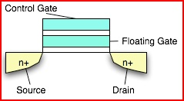

When an appropriate voltage is applied to the control gate, current will flow between the source and drain connections. However, if the floating gate has been previously charged with electrons, the charge opposes the voltage of the control gate, and current does NOT flow. Storing electrons (or not storing) electrons on the floating gate is part of the “Write” process. Once electrons are stored on the floating gate they cannot dissipate because they are completely surrounded by insulating material. Storing electrons on the floating gate involves a process called “hot electron injection”, and removing electrons involves a phenomenon called “electron tunneling,” which is one of the effects of quantum mechanics and the particle-wave duality of matter. At this point I’m in way over my head. Feel free to research quantum mechanics on your own.

A simple (but incorrect) analogy of electron tunneling is to visualize rolling a small ball on a carpet that has a large wrinkle in it. If you roll the ball slowly, when the ball reaches the wrinkle it does not roll over it, but instead rolls back, unable to cross the barrier. Roll the ball faster, and it will roll over the barrier and reach the other side. The ball does not destroy or alter the barrier, it simply does or does not roll over the barrier, dependent on its velocity. Stretching the analogy a bit (a whole lot actually) to our memory cell, the carpet wrinkle is the insulating material. But in quantum theory the ball doesn’t roll over the wrinkle, it rolls THROUGH the wrinkle without destroying or altering it, hence the term “tunneling electron”.

Erasing a cell removes the electrons from the floating gate setting the cell to a logical ”1” state. Writing to a cell adds electrons to the floating gate, changing its state to logical “0”.

Figure 2 is an example of a cell being erased. Any electrons on the floating gate tunnel through the insulating layer to the drain connection, leaving the cell in a logical “1” state.
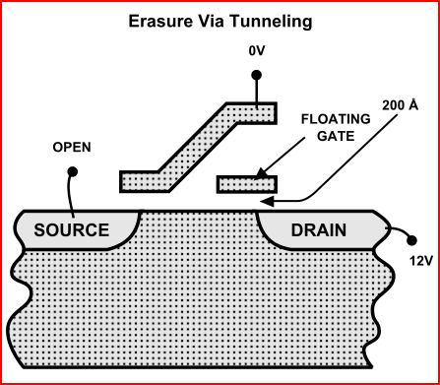
Figure 3 illustrates how a cell is set to a logical”0” state by injecting electrons onto the floating gate. The voltages shown in these figures will be somewhat different depending on the chip manufacturer. Sometimes the voltages needed to erase or write a cell may exceed the voltage available from the basic power source (such as the battery power in a digital camera) so in this case the controller chip will be designed with tiny power converters on the chip called “electron pumps”. These “pumps” provide the voltages needed.
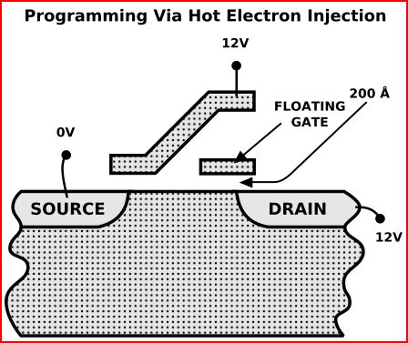
Slc and Mlc
All discussion to this point had been based on Single Level Cell (SLC) technology. That is, a single cell contains a single bit, either zero or one. However there are a number of manufacturers who are now producing Multi Level Cell (MLC) memories where a given cell contains more than a single bit of data. The concept is based on the idea that the level of charge placed on the floating gate can be varied during the write cycle. In theory, the concept could incorporate many bits into a single cell, but at this point in time a typical MLC carries information for two bits. The state of a completely erased cell is “11”. Then depending on how the write potentials are controlled, the cell can also contain “10”, “01” or “00”. When the cell is read, the controller detects how much current the cell permits to pass. Either “no current”, “low current,” “medium current” or “high current” represents the four possible states. Although this increases the complexity of the controller chip, the same memory capacity can be achieved with just half the number of memory cells, a significant advantage to the manufacturer. This advantage gets passed on to the user in a lower cost device that performs just as well as SLC. Many of the newer SSD’s use MLC technology.

Figure 4 shows how individual cells are interconnected into rows to form eight bit “Words” which share a common layer of semiconductor materials. Sequentially strobing each of the word lines will result in a serial stream corresponding to the data written into each cell. The design results in an inversion of voltages and logical state, so the array is know as NAND (NOT AND) flash.
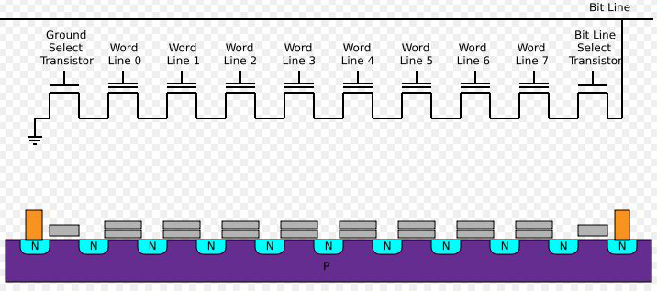
NAND memory arrays can be very compact as compared to other structures such as NOR gates, and require a minimum of connections to or between cells. This allows more memory to be designed into a given area of silicon, increasing yields and reducing costs. A by-product of this design is that although “zeros” can be written to individual cells, writing a “one” cannot. The entire block must be “erased” to an all “ones” state before it can be written to again.

Memory Controller
The memory cells cannot control themselves, they are simply storage. To make the device useful it also requires a “controller” which performs multiple functions. First, it makes the memory array appear to the operating system as if it is a disk drive, and secondly it translates the read and write commands from the operating system to a form that the NAND flash can use. It also contains a small amount of read/write cache for temporary storage, and can also perform block erasures.

Memory Organization
The memory is arranged into “pages” and “blocks”. The smallest increment is the “page” with multiple “pages” being combined into “blocks”. Both page and block size can vary in order to provide the total storage capacity being designed into the device. Some typical configurations are shown below.

• 32 pages of 512+16 bytes each for a block size of 16 KB
• 64 pages of 2,048+64 bytes each for a block size of 128 KB
• 64 pages of 4,096+128 bytes each for a block size of 256 KB
• 128 pages of 4,096+128 bytes each for a block size of 512 KB

The most commonly used configuration uses 256 KB blocks with 4 KB pages, but as seen above a given manufacturer may choose another configuration. In the manufacturing process it is recognized that not every cell will be perfect, so additional cells are included, as shown in the table above. The extra bytes are used to mark bad pages and also incorporate error detecting bits that are accessed by the controller during read/write operations. If an error is detected, the page is marked “bad” and will not be used again. In better devices the error code configuration can correct single errors and detect double errors. Extra blocks are often included in the device which can be “swapped in” to maintain the designated capacity as blocks fail over time.

Note that the page and block structure of the memory device is totally different from the sector-cluster-track organization of a rotating hard drive. The controller “translates” the page-block structure into sector-cluster-track and vice versa so the operating system sees the device as a hard drive.

Flash (or Thumb) Drives
The simplest form of solid state drive that we are all familiar with is the simple USB “Flash Drive.”

Figure 5 shows a thumb drive that has been opened up and you can see that the NAND flash and controller are two different devices connected to a common miniature circuit board. Flash drives have been available for some time, and I would guess that every home computer user has at least one.

As the cost of NAND flash has steadily dropped it has led to the availability of much larger capacities at relatively reasonable cost. This larger capacity solid state drive is commonly known as an SSD.
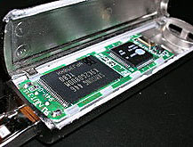
Figure 6 shows a typical SSD with its protective covers removed. Although much larger than the flash drive, you can see that the architecture is much the same, with memory chips on the left and controller chips on the right.
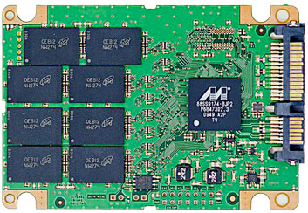
SSDs are now available in sizes that allow the complete operating system to be stored on the device as well as room for swap files and other folders the user might want on the drive. Why an SSD instead of a regular hard drive? One answer. SPEED!

A normal rotating hard drive has a track-to-track delay reaching a specified track (seek time) and then must wait for the desired data to rotate under the head where it can be read (latency). SSDs don’t have any moving parts to worry about. Once the controller computes the address, the data is immediately read without further delay and given back to the operating system.

The result is very fast read cycles, much faster than can be duplicated by any rotating hard drive. When the operating system resides on an SSD, the computer will complete the boot process in seconds, rather than minutes. If the “swap file” also resides on the SSD, “swapping” occurs much faster as well since data is being swapped to memory, rather than a hard drive with its seek and latency delays. However we will soon find that writing to an SSD can take more time than expected, especially if it has been in use for a while. We will find out why in a moment.

Wear Leveling
Unfortunately, over many erase-write cycles the insulating material around the floating gate deteriorates, and the cell fails. (Reading a cell causes no damage.) A typical cell will function reliably for over 100,000 erase-write cycles before it fails. (Some manufacturers now claim they have improved reliability to over 1 million cycles.) To reduce the number of times a given group of cells (a page) is cycled, every time the controller writes data it selects previously unused pages, spreading the “wear” over all pages, instead of allowing all activity to occur over and over in the first few pages. This greatly extends the life of the device. Deleted pages remain unaltered. They are flagged as deleted, but the data still remains. Deleted pages do not get reused at this time.

Some manufacturers over provision the number of blocks inside the SSD. As blocks eventually fail, the controller marks them bad so they are never reused. The controller is able to assign a replacement block from this pool of reserved memory, thereby maintaining the advertised capacity of the device, even though some blocks have failed.

Reading and Writing an SSD

Figure 7 shows a simplified SSD. In this example we will assume a non-standard block size of five pages. We are going to write a small .DOC file (less than 4K) to the SSD.
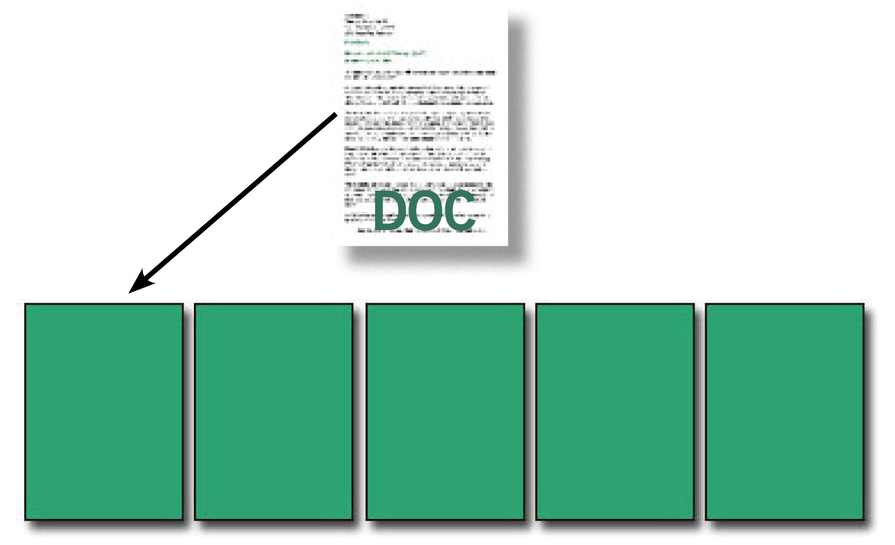
It all fits into the first page nicely as shown in Figure 8. Now we want to write a picture of a boy into the memory.
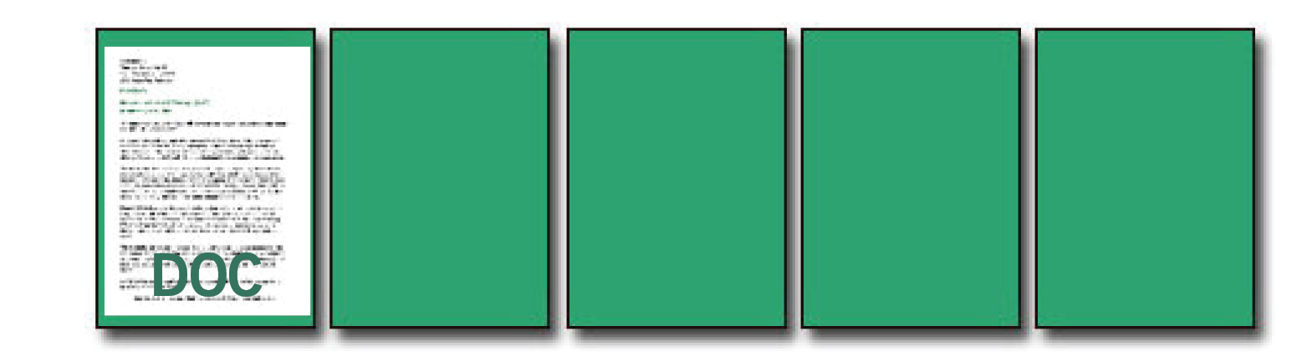
As can be seen in Figure 9, there is space, so no problem.
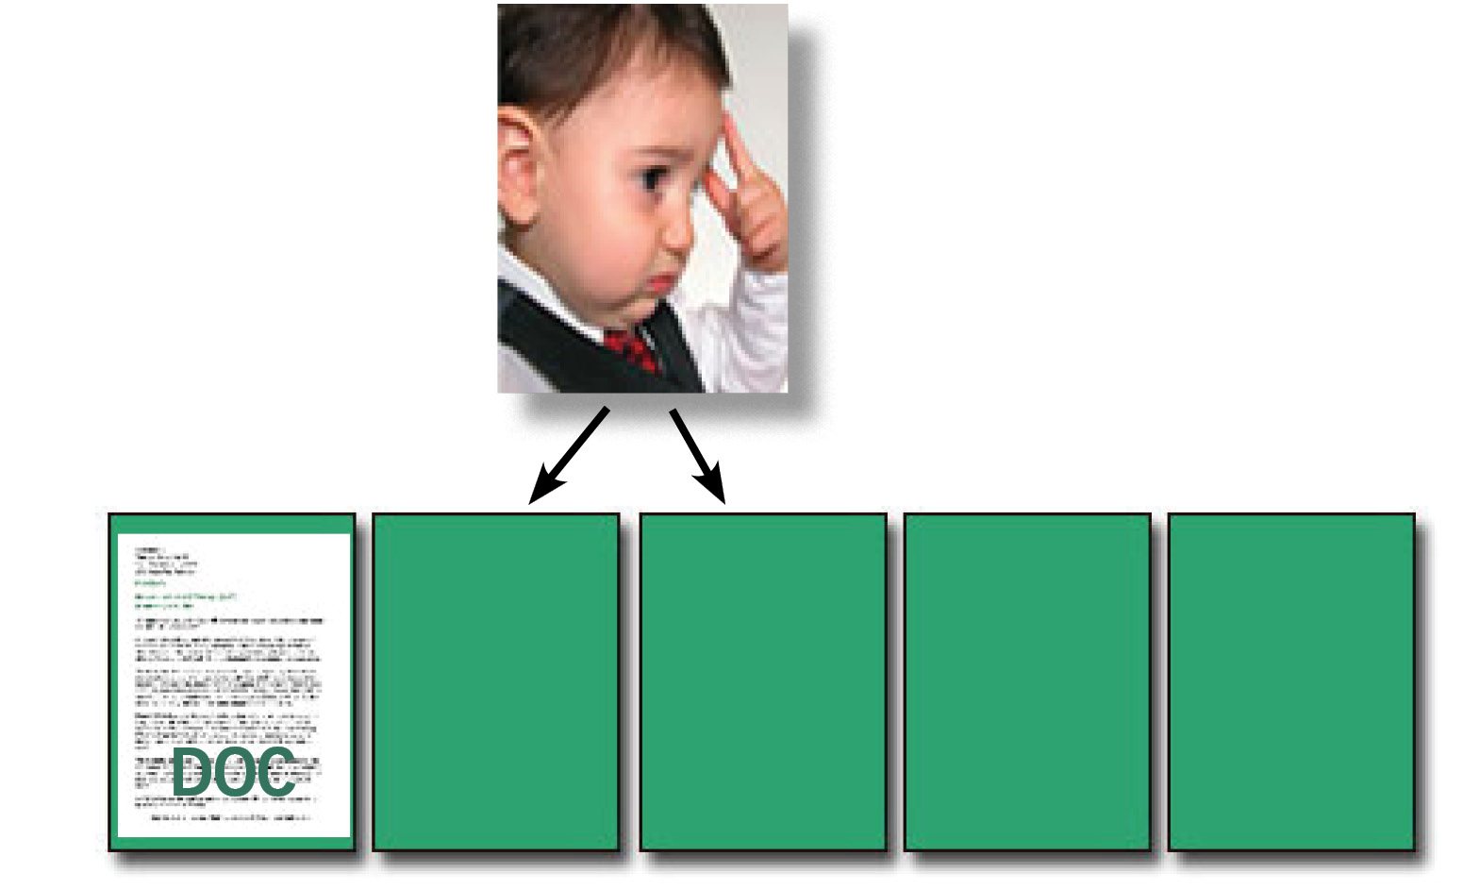
As we continue on, we decide that the .DOC file is no longer needed, so we delete it. Next we decide to save a 24KB picture of the sun’s rays as shown in Figure 10.
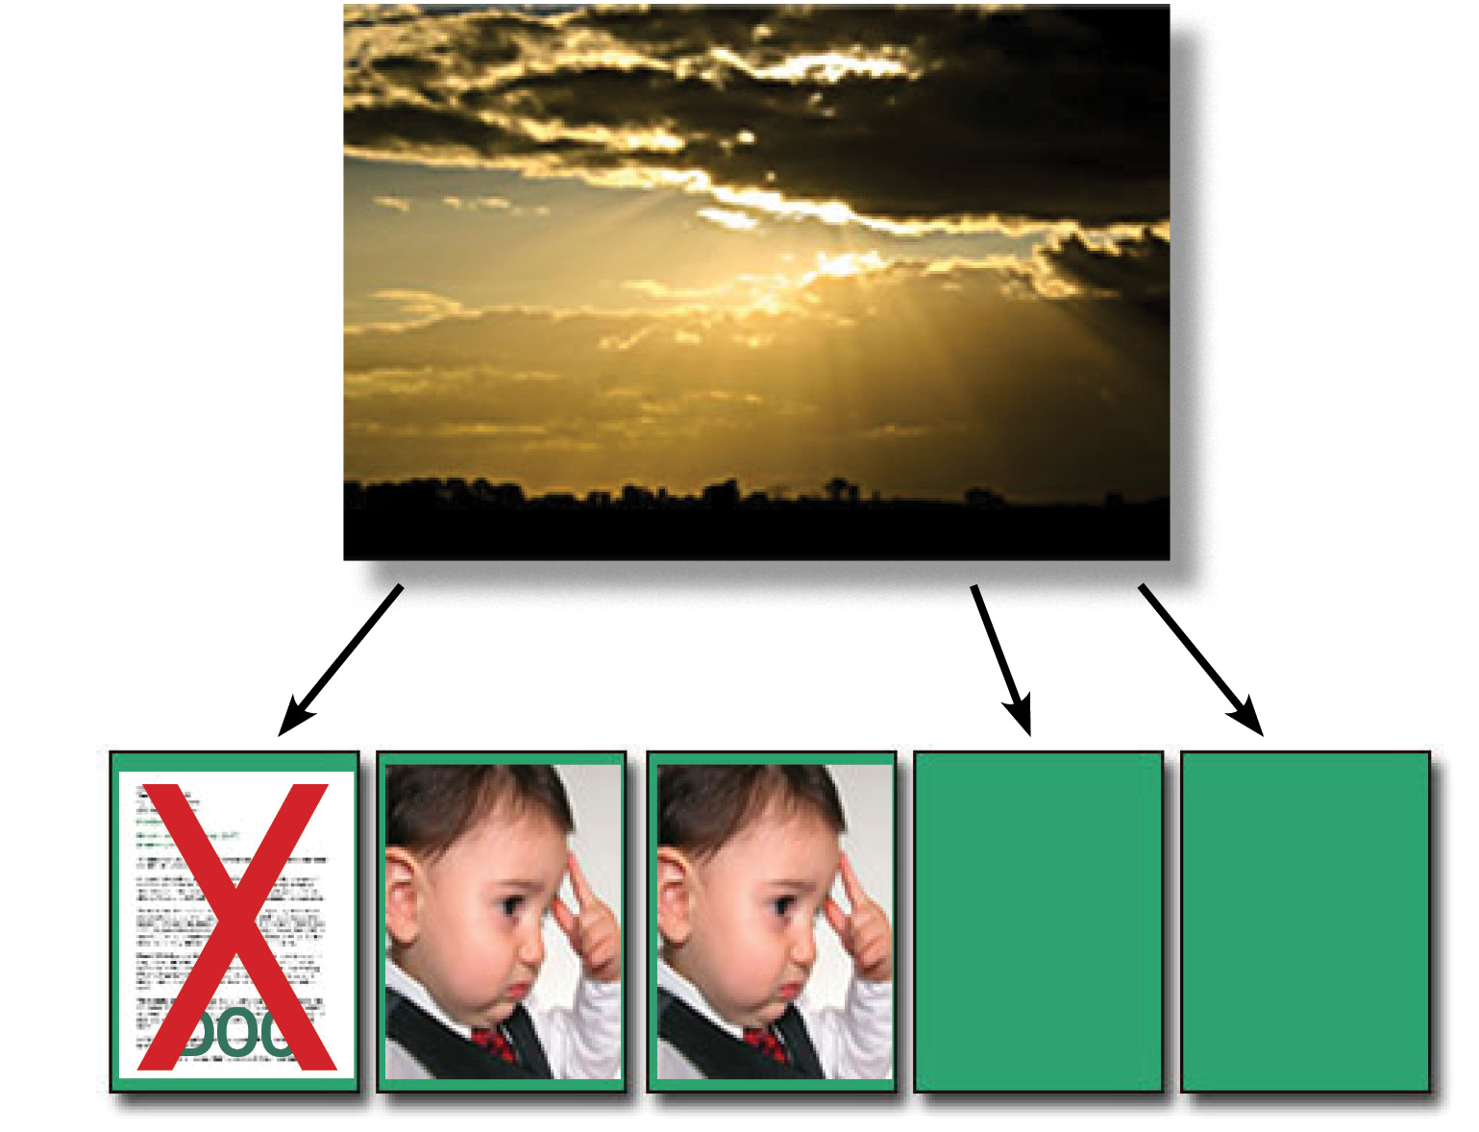
Problem…we don’t have enough empty pages left. Although the first page contains a deleted file it cannot be used because the data is still there. Remember, we can only write zeros, so if the new data requires ones where zeros existed before in the deleted page, we are in big trouble as the result would be junk.

The controller is able to sense this condition and must now do something to resolve the problem.

Departing momentarily from our single block memory example, a real-world SSD would have many blocks, so the controller would start searching for blocks where all pages are marked deleted. When such a block was found, the entire block would then be erased, making all pages available, and then the data would be written to pages in the newly erased block. The result? Substantially increased time required to write data to the SSD, slowing down the overall write timing.

This is why an SSD seems to be fast when new, but then gets slower as time goes on. The controller has to perform “garbage collection” before each write cycle. Remember that with wear leveling a page of data gets written to a new physical location each time it is written.

Why is there this breakdown in communication between the SSD and the OS? If we look at how a rotating disk drive functions, a given sector if marked available can be completely overwritten by the magnetic head as the magnetic material on the disk spins underneath. The magnetic head is able to record both zeros and ones on the magnetic material regardless of what existed prior to the current write pass. Since the OS assumes a rotating standard disk drive it is not necessary for the OS to give the drive any sort of erase command. Erasure of preexisting data occurs automatically when new data is written. With SSDs as we have already learned, due to the nature of the NAND design, data cannot be written over prior data. The prior data in a page must be erased before a new write can occur on that page.

What if there was a way to tell the SSD controller that you are done writing for a while, and that the controller should start its garbage collection process now, while the system is not reading or writing to the SSD? Then the next time you needed to write the SSD would have empty pages available.

There is a way. Introducing the “SandForce” controller and the “TRIM” command.

Figure 11 is a photo of one of the new SSDs which uses the SandForce controller. The new controller is conspicuously labeled on the left side of the memory chips.
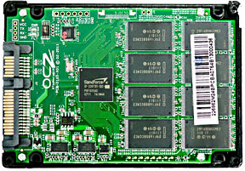
The Sandforce Controller
In 2009 OCZ Technology introduced a new version of its SSD and called it the OCZ Vertex 2 Pro. The new drive incorporated a new controller from a company called SandForce. As a company SandForce is a bit unique. They only manufacture NAND flash controllers. Users of their product need to purchase the flash memory elsewhere.

The SandForce controller offered a significant advantage over other controllers in that it used an internal time-out function that would initiate garbage collection soon after reading or writing had momentarily stopped. It had an even better feature. If the system OS could send it a new “TRIM” command, the process could be started even sooner, further improving performance. Since the process was implemented entirely within the controller, there was no involvement of the computer’s CPU or RAM. So there was absolutely no performance penalty on the computer.

The SandForce chip also performs file compression to increase the amount of data that can be stored in the SSD. The amount of compression depends on how much compression has already been applied prior to saving. ZIP and JPG files cannot be compressed much; EXE files can be compressed to some extent (they are somewhat compressed by design); raw data being stored can be compressed to a greater extent. I’m still researching how it is implemented in the chip.

Not all SSDs use the SandForce controller, so if you are in the market for a SandForce-based SSD make sure the SSD you plan to purchase uses the SandForce controller. If you intend to use multiple SSDs in a RAID configuration you don’t need the SandForce controller since it will not work with RAID. This may change in the future.

Trim Command
The TRIM command is now being implemented in several different operating systems.
The main ones are:

- Windows 7
- Windows Server 2008 R2
- Apple Mac OS 10.6.8
- Linux Kernel 2.6.33

Remember our earlier example in Figure 10? Let’s see what happens in an SSD first without TRIM and then with TRIM.

Figure 12 shows the steps that are incurred by a write command when TRIM is not implemented. The cache in the controller is implemented with normal volatile read/write RAM, so each part of the cache can be read or written to without requiring block erase.
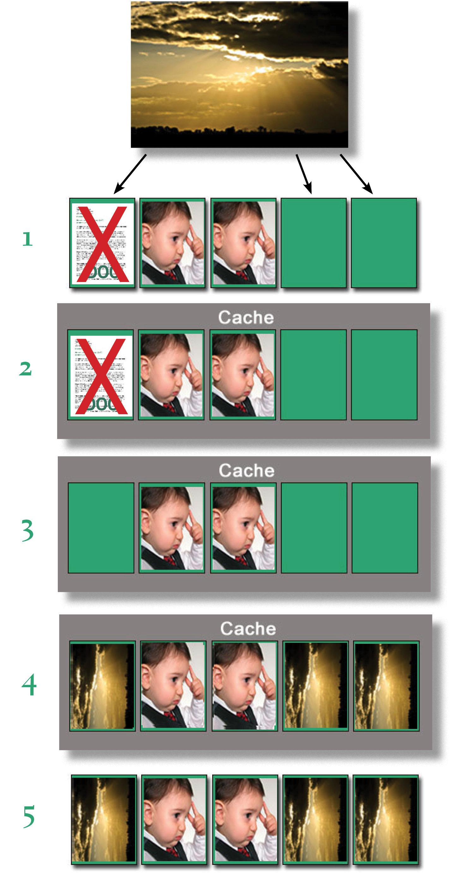
Row 1 shows our initial attempt to write to a SSD NAND block with insufficient pages. It cannot complete without further intervention by the controller.

Row 2 shows that first the entire NAND block is read into the controller’s internal cache. There the controller determines that the page that previously contained the .DOC file was marked DELETED, so it is in reality an available page.

Row 3 shows that the controller has erased the first page, making it available. Now there is sufficient space for our 24KB picture.

Row 4 shows that the available pages in cache have now been used to store the image.

Row 5 shows that the NAND block can be block erased, and then the cache data written into it. (The new block may in fact be in a different location because the wear leveling algorithm may have come into play during this process.) The block now contains both images and the residue from the .DOC file is gone. Note that until all these steps are completed the write operation has been delayed, substantially increasing the time required to write the data. At this point the controller signals the OS that the write is complete and the OS can continue writing the next page with whatever new data needs to be written. If no available pages can be found, the above procedure must be repeated. This accounts for the slowdown of an SSD once it has been in use for a period of time.

Figure 13 shows how a completely different sequence occurs when the SSD can implement the TRIM command. Let’s momentarily go back to Figure 9, where we are attempting to write the “boy” picture. Remember that we have already deleted the .DOC file by now. After the block containing the picture and the deleted file are written into cache, the controller sends an acknowledgement that the write has been successful. Then the OS sends a TRIM command signifying that the write process has ended.
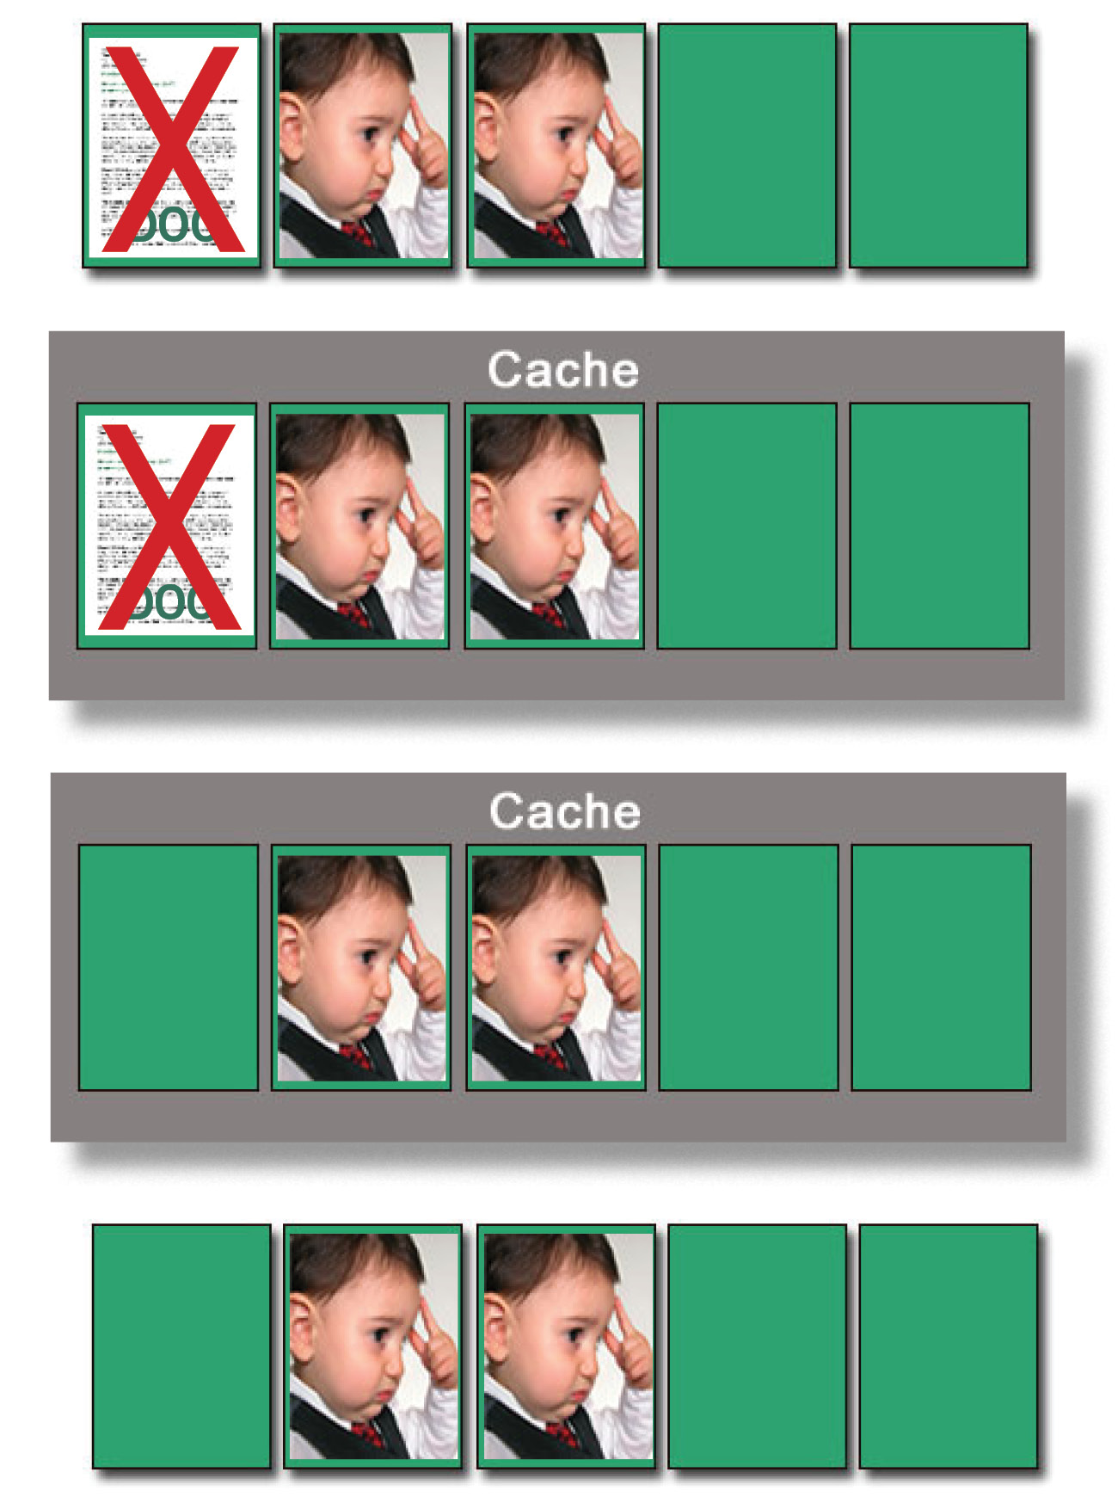
The controller erases the deleted file which was in the first page while the block is still in cache. Then the block is written to an available “clean” block, or to available clean pages. Note that the later steps are occurring as a background process, and the OS does not need to wait for the additional steps to complete. This substantially speeds up the write process. Further, the TRIM command creates additional clean pages to which data can be written without waiting for block erasures to be processed before the next write occurs.

If the SSD has signaled a successful write, what if power should be removed before the data can actually be written into the NAND flash? To solve that potential problem, most SSDs have an on-board capacitor which stores sufficient power to complete the internal erase and write processes.

Caveats - Secure Erasing
Now, on to the subject that started all the inquiry to the above; securely erasing data from an SSD.

Existing secure erase programs are based on the assumption of conventional hard drive design. The secure erase algorithm overwrites pseudo-random garbage into the deleted sectors (often multiple times) to be sure that no magnetic residue of the original data can be detected. But with the wear leveling process built into the SSD, each time there is a new write, the data gets written to a different page or block, reducing the “wear” of a given block.

Result? The pseudo random data is written into new blocks or pages, leaving the deleted pages intact. Someone with proper forensic tools could still access and read the deleted data, since it was never actually erased or overwritten. (Obviously, depending on how many times the pseudo-random data is written some blocks or pages will be covered up by the pseudo-random garbage, but some data will still be intact.)

How does one get around this problem? One way is to encrypt the data before it is written. Without the encryption key the recovered data is still garbage. Another way is to set up the programs handling the secure data so they never write to the SSD. However that approach will only work if the OS swap file is assigned to another drive, not the SSD. Otherwise pieces of the secure data might still be exposed in the swap file assigned to the SSD. If the computer is going to be passed on to someone else or discarded, it is essential that all private data be forever gone before the hand-off.

Secure data is probably not an issue for most of us, but if the computer is used for business purposes, it might contain private information such as employee names, addresses, social security numbers or performance evaluations. We obviously don’t want that information to fall into the wrong hands. For some people the only absolute solution of assuring an SSDs data is unavailable is to remove the SSD and forcefully apply a sledgehammer multiple times. Perhaps a bit draconian, but very effective.

Reducing Wear
Since we already know that memory cells have a finite number or erase write cycles, what steps can we take to extend the life of an SSD? Remember, reading an SSD does not produce wear, only writing. One way is to reassign system folders to standard hard drives. Windows as its default will assign all the user files (Documents, Pictures, Music etc.) to the C: drive. Although the system response will be very fast if these reside on the SSD, the result will be a lot more write cycles, incrementally shortening the life of the SSD. If the swap file is located on the SSD, that too can result in a lot of write activity, although there are a couple of ways to mitigate the problem. If you are using a 64 bit OS you can add large amounts of RAM to the system. Since there is so much RAM, the OS will seldom need to perform swaps.

Probably the best means of limiting wear is to have the SSD contain only the Operating System and nothing else. That way only OS updates and patches get written to the SSD. Anything else gets written to a standard hard drive. The user gets the advantage of speedy boot times. The trade-off is that the standard hard drive is slower than the SSD, so other operations occur at normal speeds.

For some people, the speed advantage outweighs the life issue, especially if they buy a new computer every couple of years, so they put as much as they can into the SSD. If they use a much larger SSD, the wear gets distributed over the larger amount of memory, extending the life of the SSD. How you plan to use your computer and what you want in performance will really determine how to set up your SSD.

Defragging
Only one comment here. Never ever defrag an SSD. First of all, since an SSD has no latency or seek time issues, defragging will do nothing to speed it up, despite what a defrag utility might report. The wear leveling processes going on inside an SSD will make it appear that what should be contiguous data is spread all over the memory of the SSD. In fact it is, but it is of no consequence since there are no mechanical parts that have to move to get to the data. Worse still is the fact that all the writing that the defrag process invokes simply shortens the life of the SSD. And when the defrag process completes (if it can) it will still show the SSD in a highly fragmented state because the wear leveling algorithm has completely thwarted what the defrag program is trying to do.

Whatever you do, don’t assign one of those auto defragging programs such as Diskeeper to an SSD. There are hints in various forums that the PRO version of Diskeeper 2011 can handle SSDs but I find nothing on their web site that confirms this.

References
Much of the above information was gleaned from sources such as Wikipedia, and discussions on a variety of user forums.

Ted Wirtz retired from Pacific Bell Network Engineering in December of 1991 after 34 years of service. After being totally bored out of his skull, he found a "retirement" job at a local craft store (Tall Mouse Arts and Crafts) working in their IT department, installing and maintaining computers for both their back office and point of sale networks. The location was ideal since it was within the local area instead of the Los Angeles area. Ted enjoyed the work so much that he stayed with them for 16 years before finally re-retiring in 2009. Ted is retired for good now and enjoying every minute of it, traveling to such far away places as Santa Barbara, San Diego, and Anaheim's Disneyland.
FIGURES (Attached) WITH CAPTIONS

Figure 5
A USB flash drive. The chip on the left is the flash memory. The controller is on the right.

Figure 7
The green boxes are empty pages

Figure 9
The picture is 8KB and thus occupies two pages, which are empty.

Figure 10
Problem. There aren’t enough empty pages.

Figure 13
The TRIM command forces the block to be cleaned before our final write. There’s additional overhead, but it happens after a delete and not during a critical write.

